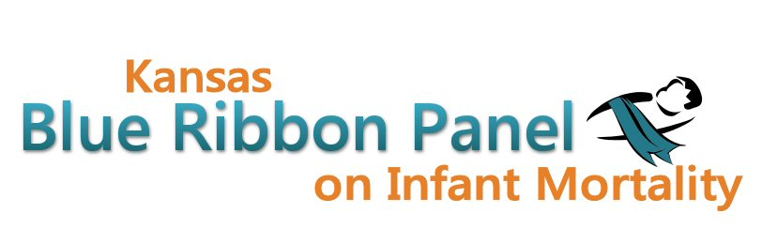
Infant Mortality Campaign Tracking Log Form
(September 2011 – Infant Mortality Awareness Month)

Organization Name: _____________________________
Contact Person Name: _____________________________
Phone/email address for questions: _____________________________

Please add rows and new tables as needed to record activities during the month. Or, if you work better in Excel spreadsheets, please do so. After September, please continue to use the form but change the header above to reflect that you are now completing information for October and then November.

Type of media  or activity focused on infant mortality | Name of newspaper, TV station, magazine, agency or special event where presentation made, flyers distributed, etc. | Date of Activity | # of times aired or  # number of materials distributed | Estimated # reached (estimated listenership, readership, viewership)
Radio interview
TV interview
Newspaper
Radio Public Service Announcement (PSA)
TV PSA
Magazine
Newsletters
Flyers, brochures, etc.
Billboards
Presentation
Health Fair
Special community event
Website hits
If radio, TV, newspaper ad or public service announcement (PSA) is released more than once in time period covered by this form, indicate number of times. Multiply this number times the estimated audience reach (number of listeners/readers/viewers) for the radio, TV, or newspaper.

Example: A PSA for Infant Mortality Month airs 4 times in September. The listenership of the station is 3,000 people. Estimated total number reached will be 4X 3,000. (12,000 reached—not just 3,000). Sample table below:

Type of media  or activity focused on infant mortality | Name of newspaper, TV station, magazine, presentation made, flyers distributed, etc. | Date of Activity | # of times aired or  # number of materials distributed | Estimated # reached (listenership, readership, viewership)
Radio interview | KRQT | 9/14/2010 | 4 | 12,000 (4x 3,000 estimated listeners)
TV interview
Newspaper | Fredonia Times article | 9/16/2010 | 1 | 5,000
Radio Public Service Announcement (PSA) | KRQT | 9/12, 9/14,9/16, 9/18 | 4 | 16,000 (4x 3,000)
TV PSA
Magazine
Newsletters | Health Department Family Health newsletter | 9/28 | 1 | 2,000
Flyers, brochures, etc.
Billboards
Presentation | Healthy Community Coalition | 9/20/2010 | 1 | 35
Health Fair | Healthy Start – Prairie Fall Festival, Haysville – Healthy Families booth | 9/22/2010 | 1 | 300
Special community event | Jimberee – Community Night for new parents  Healthy Start booth | 9/27/2010 | 1 | 500

